## 结果截图

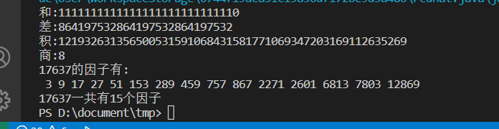

## 代码截图

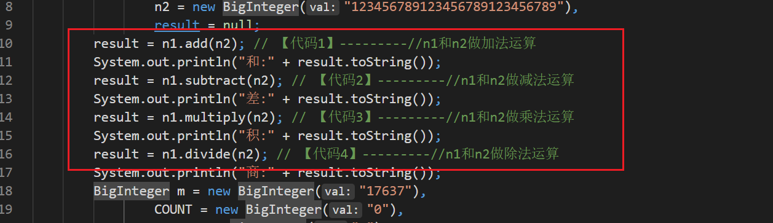

## 源码

package chapter8_4;

import java.math.*;

public class HandleBigInteger {

public static void main(String args[]) {

BigInteger n1 = new BigInteger("987654321987654321987654321"),

n2 = new BigInteger("123456789123456789123456789"),

result = null;

result = n1.add(n2); // 【代码1】---------//n1和n2做加法运算

System.out.println("和:" + result.toString());

result = n1.subtract(n2); // 【代码2】---------//n1和n2做减法运算

System.out.println("差:" + result.toString());

result = n1.multiply(n2); // 【代码3】---------//n1和n2做乘法运算

System.out.println("积:" + result.toString());

result = n1.divide(n2); // 【代码4】---------//n1和n2做除法运算

System.out.println("商:" + result.toString());

BigInteger m = new BigInteger("17637"),

COUNT = new BigInteger("0"),

ONE = new BigInteger("1"),

TWO = new BigInteger("2");

System.out.println(m.toString() + "的因子有:");

for (BigInteger i = TWO; i.compareTo(m) < 0; i = i.add(ONE)) {

if ((n1.remainder(i).compareTo(BigInteger.ZERO)) == 0) {

COUNT = COUNT.add(ONE);

System.out.print(" " + i.toString());

}

}

System.out.println("");

System.out.println(m.toString() + "一共有" + COUNT.toString() + "个因子");

}

}